Paper Review of Cheng by 07/07 /2020

* Title: An Efficient Reverse Geocoding Method based on Global Subdivision Model
* Needs
  + Different reverse geocoding services are used in different countries to convert the coordinates obtained by GPS to a readable street address that is easier for users to understand
  + The computing quantity of reverse geocoding is huge, especially the performance of the algorithm on the mobile terminal is not good enough
* Objectives
  + Need an algorithm with small amount of calculation and adjustable precision
  + Can retrieve nearest neighbors of spatial objects
* Methodology
  + The authors use Geohash to encode all spatial data and map multidimensional spatial data to one dimension to simplify the retrieval time complexity
  + The longer the length of the Geohash code, the more accurate the encoding of the position.
  + Concrete method: If a point object is on the left side of the 0-latitude line, the code starts with 0 and the right side starts with 1. Then, divide each square with a vertical line. Add a '0' to the Geohash code of point objects below the vertical line, and add a '1' to the Geoha sh code of point objects above the vertical line. This division continues until the required accuracy is achieved.

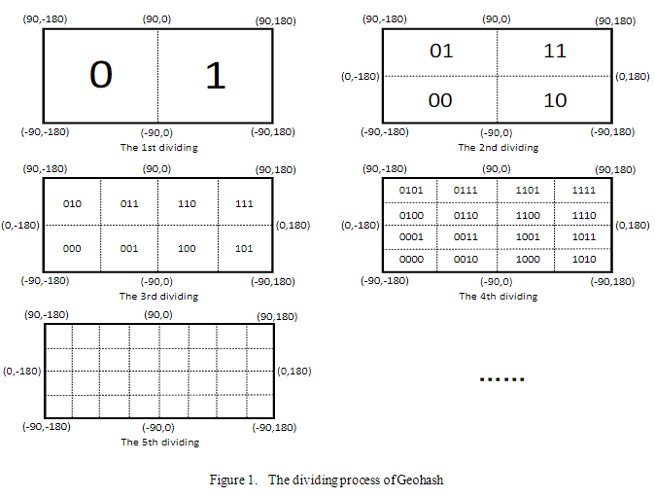

* + For larger objects, the authors choose an adaptive GeoHash method, which automatically selects the appropriate accuracy through the edge coordinates of the object.
  + The authors devised a method to detect the position of other objects in 8 neighborhoods near the estimated area using the similar characteristics of GeoHash prefixes at similar locations
* Results

The authors randomly selected 1000 points in the Beijing area as input points. After testing, they found that 99.3% of the data can be recorded completely accurately, which can meet the needs of most cases.

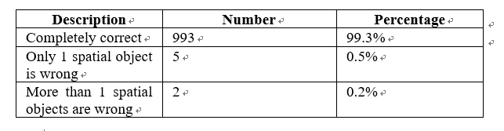

* Conclusion
  + The authors use the Geohash algorithm to map the multi-dimensional spatial data of GPS coordinate information into a one-dimensional string, which is convenient for the storage and retrieval of the database and simplifies the time consumed for retrieval
  + The Geohash algorithm used by the authors can provide higher accuracy, and the accuracy can be adjusted according to different situations